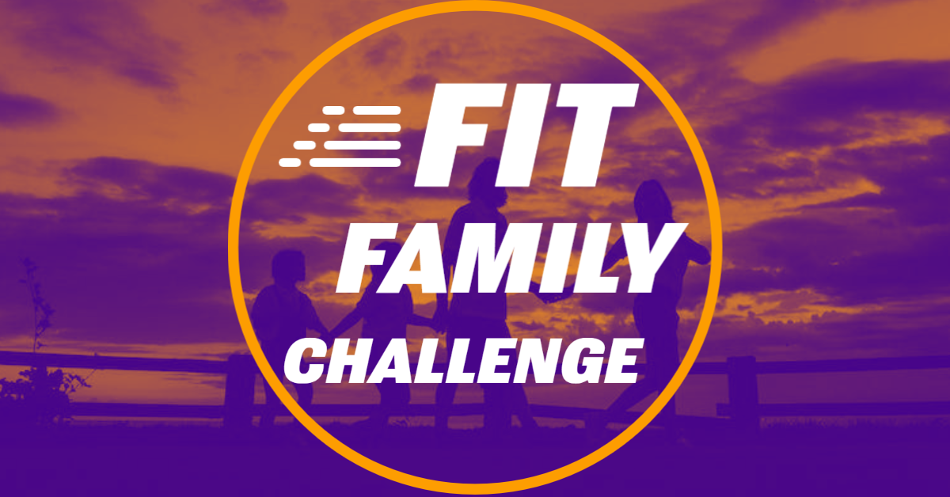

Register for all 3 local 5K walk/run events (5KXCV-KRNW Run for Radio, Speedy Spoofhound & Ben’s Stockings of Hope Memory Walk) and be eligible for our family prize drawings!

FIT FAMILY CHALLENGE PRIZES:

Mozingo: 14 rounds on the Watson 9

Mozingo: 2 rounds on the Sechrest 18

Mozingo: One-night Cabin Rental

Hangar: 4 hours in the event space

MPR: 10 day passes to the pool/gym

MPR: One 15-punch card & Five 5-punch cards

Mustangs Baseball: Family 4-pack

Worlds of Fun: 4 single day admission tickets

For information or Registration:

APRIL 15-29: 5KXCV-KRNW Run for Radio: APRIL 29: Speedy Spoofhound:

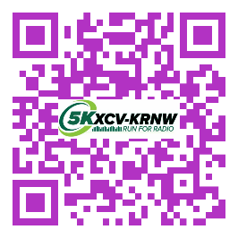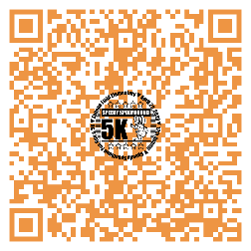

MAY 27: Ben’s Stockings of Hope Memory Walk:

