HOLIDAY 2021 Programming Schedule

Mon, Nov 29, 6PM Hanukkah Lights
Tues, Nov30, 6PM Candles Burning Brightly
Wed, Dec 1, 6PM All Is Bright: Contemplative Music for Christmas
Mon, Dec 6, 6PM Christmas with the Mormon Tabernacle Choir & Orchestra
Tues, Dec 7, 6PM Hollywood Holiday
Wed, Dec 8, 6PM Welcome Christmas
Thurs, Dec 9, 6PM A Choral Christmas with Stile Antico
Tues, Dec 14, 6PM A Soulful Christmas
Wed, Dec 16, 6PM Christmas with Morehouse and Spelman Glee Clubs
Sat, Dec 18, 11AM Festivo Alt. Latino featuring Gaby Moreno
Mon, Dec 20, 6PM Hygge Holiday
Tues, Dec 21, 6PM A Paul Winter Solstice
Wed, Dec 22, 6PM A Chanticleer Christmas
Thurs, Dec 23, 9AM The Big Tiny Desk Holiday Special
Thurs Dec 23, 10AM Joy to the World – A Holiday in Pink
Thurs, Dec 23, 11AM An Afro Blue Christmas
Thurs, Dec 23, 6PM Tinsel Tales 1: NPR Christmas Favorites
Fri, Dec 24, 9AM-Noon Tinsel Tales 2, 3, 4
Fri, Dec 24, 6PM Jonathan Winters’ A Christmas Carol
Fri, Dec 24, 9PM Jazz Night in America: A Holiday Celebration
Fri, Dec 24, 10PM Jazz Piano Christmas 37
Sat, Dec 25, 11AM All Songs Considered for Holiday Extravaganza
Fri, Dec 31, 10PM Toast of the Nation
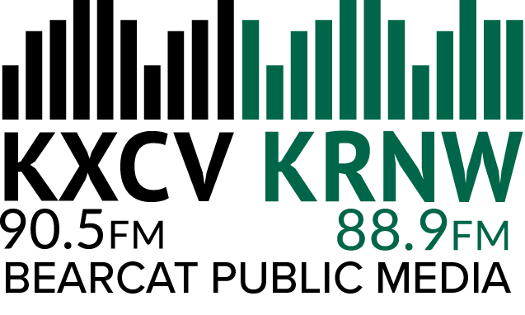

HAPPY HOLIDAYS!

From your KXCV-KRNW family

